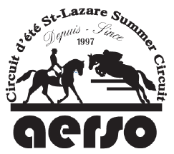
AERSO Board of Directors Nomination Form

We are accepting nominations for two positions of DIRECTOR on the A.E.R.S.O Board of Directors. Anyone interested should submit his/her name to the A.E.R.S.O Nomination Committee no later than January 15th 2021. Nomination forms will be accepted by mail at 256 Ch Scott, Rigaud, Qc, J0P 1P0 or email aerso.org@gmail.com.
Nominees must be 18 years of age or older and be current members of the A.E.R.S.O. Elections will be held at the A.E.R.S.O. Annual General Meeting on Sunday February 7th, 2021, 3 p.m. VIA ZOOM.
If you have any questions, please contact the Nomination Committee at aerso.org@gmail.com.

Name of Nominee: | 2021 A.E.R.S.O. Number:
Telephone: | Email:
Signature of Nominee: | Date:

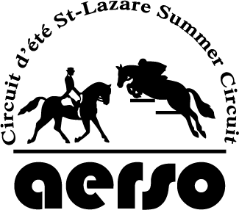
AERSO Board of Directors Nomination Form

We are accepting nominations for two positions of DIRECTOR on the A.E.R.S.O Board of Directors. Anyone interested should submit his/her name to the A.E.R.S.O Nomination Committee no later than January 15th 2021. Nomination forms will be accepted by mail at 256 Ch Scott, Rigaud, Qc, J0P 1P0 or email aerso.org@gmail.com.
Nominees must be 18 years of age or older and be current members of the A.E.R.S.O. Elections will be held at the A.E.R.S.O. Annual General Meeting on Sunday February 7th 2021, 3 p.m. VIA ZOOM.
If you have any questions, please contact the Nomination Committee at aerso.org@gmail.com.

Name of Nominee: | 2021 A.E.R.S.O. Number:
Telephone: | Email:
Signature of Nominee: | Date:

